Frankever Smart Switch

FEATURES:
- Single Press -> Load On/Off
- Double Press -> RGB LED On/Off
- If Load is On -> Purple
- If Load is Off -> Green
- Long Press till 20 seconds -> Device Reset.
- On WiFi connection, LED will indicate.
- On Load connected/disconnected, LED will indicate.

DAIS:
Device:
{
"_id": "100035e0",
"deviceTypeId": "ezlopi",
"parentDeviceId": "",
"category": "switch",
"subcategory": "in_wall",
"gatewayId": "457a5069",
"batteryPowered": false,
"name": "InWallSwitch",
"serviceNotification": false,
"type": "switch.inwall",
"reachable": true,
"roomId": "",
"security": "no",
"ready": true,
"status": "idle"
}

Item:

{
"_id": "200035f6",
"deviceId": "100035f0",
"hasGetter": true,
"hasSetter": true,
"name": "switch",
"valueType": "bool",
"value": true,
"valueFormatted": true
}

PICTURES:
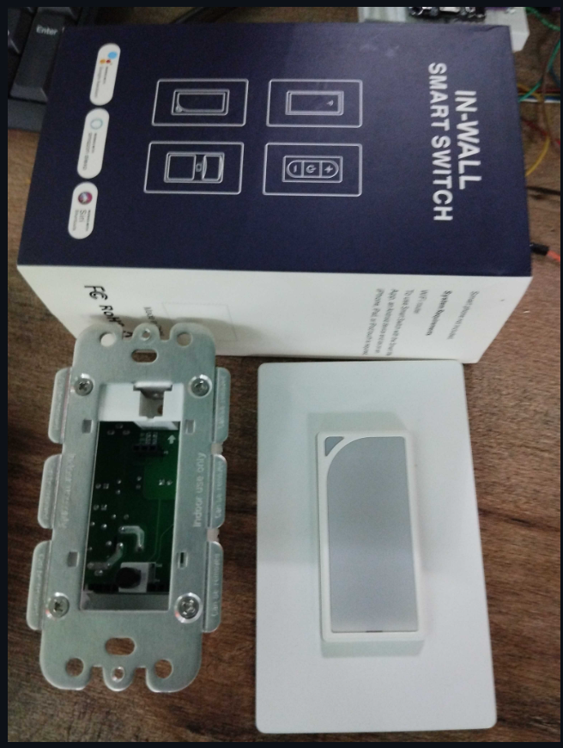
Device front side
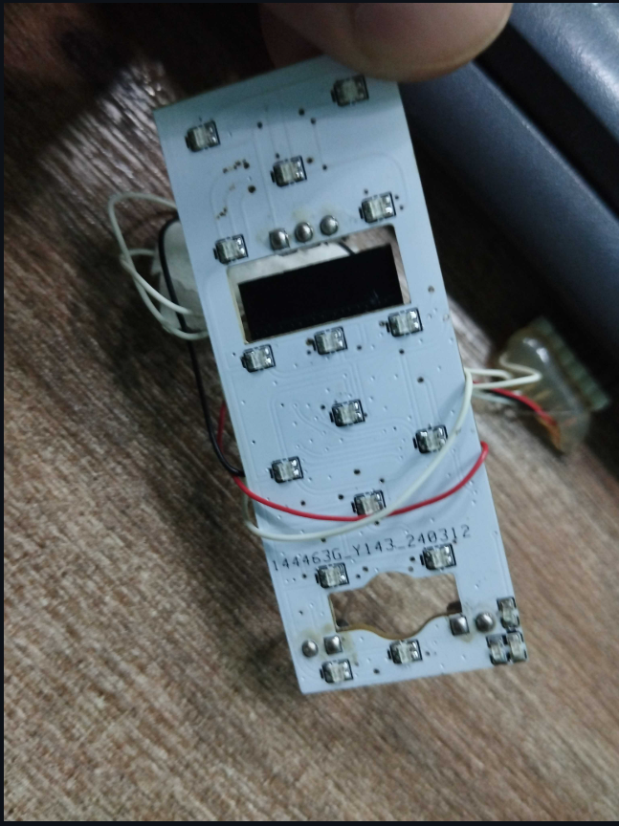 PCB Front Side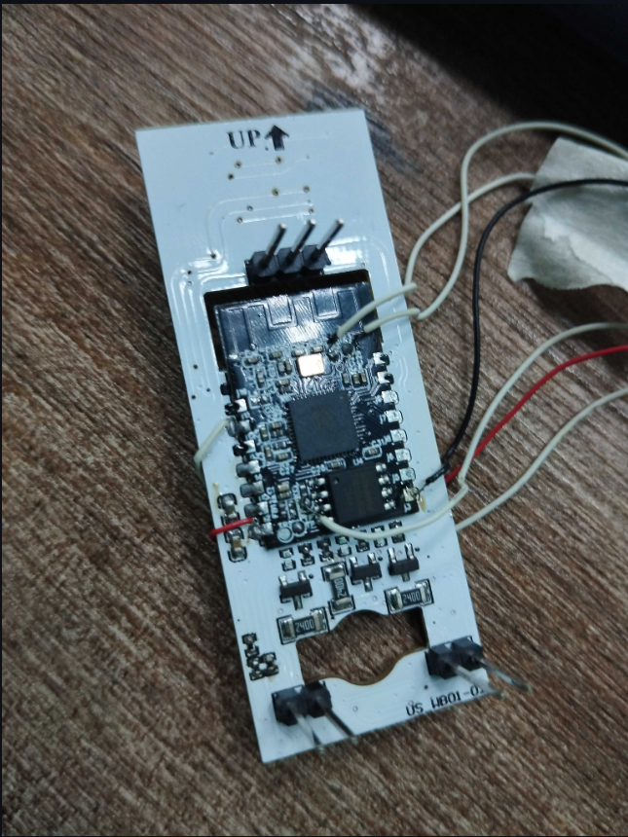PCB Back Side
GPIOS:
Gpio_in -> Gpio_16
Gpio_out -> Gpio_19

